# **GAMMALBYN 3-seat sofa, blue**

**Product details $900**

MRP Rs.27,986 (incl. tax)Durable metal springs in the seat give the sofa a springy comfort, allowing you to sit, relax and enjoy it for many years.

**Materials & care**

* **Leg:** Polypropylene plastic
* **Fabric:**100% polyester
* **Cushion cover** Machine wash, max 40°C, normal process .Do not bleach .Do not tumble dry .Iron, max 150°C.Professional dry cleaning in tetrachloroethene and hydrocarbons, normal process.
* **Frame, non-removable cover** Vacuum clean .Wipe clean with a damp cloth.

## Product size

**Height incl. headrest:**72 cm (28 3/8 ")

**Height including back cushions:**82 cm (32 1/4 ")

**Height backrest:**72 cm (28 3/8 ")

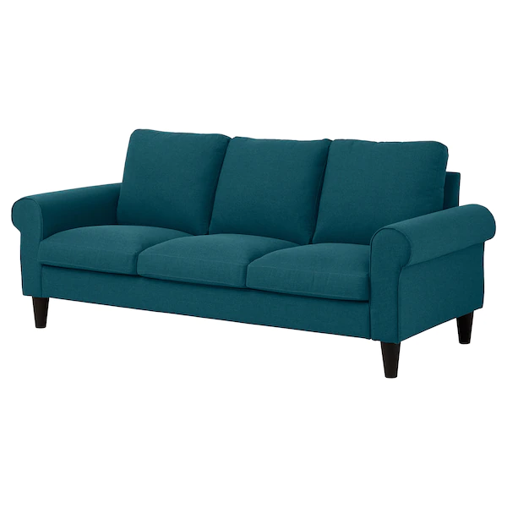**Width:**201 cm (79 1/8 ")

**Depth:**91 cm (35 7/8 ")

**Free height under furniture:**15 cm (5 7/8 ")

**Armrest width:**18 cm (7 1/8 ")

**Armrest height:**60 cm (23 5/8 ")

**Seat width:**166 cm (65 3/8 ")

**Seat depth:**54 cm (21 1/4 ")

**Seat height:**48 cm (18 7/8 ")

**Height:**82 cm (32 1/4 ")